Solution Via del Molino n° 32 C.a.p. 31030 Caselle di Altivole (TV) Tel. - Fax. ++39 0423-915549 E-mail chevis@libero.it

SMALL MACHINE-MUSICAL ACCESSORIES

FOR WOODWIND INSTRUMENTS

Tel. ++39 0423 91.55.49 Fax ++39 0423 91.55.49
www.solution-reed.it e-mail chevis@libero.it

Dear Sir Firm
OBJECT: dealer pricelist accessories 2005.

Solution company has the pleasure to offer you some extraordinary new products.
We offer you some novelties already appreciated on the musical sphere of woodwind instruments:
- Tip profiling machine (reed) type Rieger standard model for Bassoon
- Shaping machine with shaperform standard for Oboe

- CHEVIS: machines designed to make profiled gouged canes and gouged shaped canes for Bassoon and Oboe.
- WINDREED: wraps and twines the threads at the end of the reed for Bassoon and Oboe
- CUT-CANE: accurate uniform cutting of reeds for bassoons and contra-bassoons.
- CUT-REEDING: professional model for Bassoon and Oboe
- CUT-REEDING POCKET: professional model for Bassoon and Oboe pocket

Besides the above products mentioned we offer you a large range of appropriate accessories, ( sharpener for clasp knife “pocket”, bassoon mandrel wooden handle “pocket”, Dial-indicator of reed-thickness pocket., tempered steel knife razor type "thin" professional model, handle for interchangeable mandrel/reamer Ø 6).
Now it is possible to order a new model small machine to gouged type Rieger Bassoon and Oboe.

TERMS OF PAYMENT: for the first order payment in 30 days (depending on the value also 60days).
In case of high values (more than 3.000 Euro), you are expected to give a 40% advance and then full payment in 30-60 days.
METHOD OF PAYMENT: bank transfer in Euro/Dollar or cheque in Euro/Dollar.
DISCOUNT: Our Company usually gives an estimate on orders more than 25 pieces(for each item) in order to offer a customized discount.
We normally allow a 5% discount on 10 quantity order (every accessories, for each item, exclusive of cane and reed ).
Please note that we already sent you our wholesale catalogue and pricelist.
For more information on our products and to consult the 2005 pricelist call our commercial office, from 9.00 am to 12.30 pm and from 2.30 pm to 6.00 pm, from Monday to Friday at the following numbers:
Tel ++39 (0)423 /915549 Fax ++39 (0)423/915549 e-mail chevis@libero.it
If it’s necessary longer than working time and on week-end, you can call our commercial manager number:
Mobile++39 347/1623363
For information in French, you can call from 4.30 pm to 7.00 pm, from Monday to Friday at the following number:
Mobile ++39 349/7112006
For other explanations of technical details and assistance, also call our technical service asking for Mr. Palbert.

Best Regards

SOLUTION
Commercial manager
Davide Patrizi

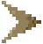
FOR DOUBLE AND SINGLE REEDS

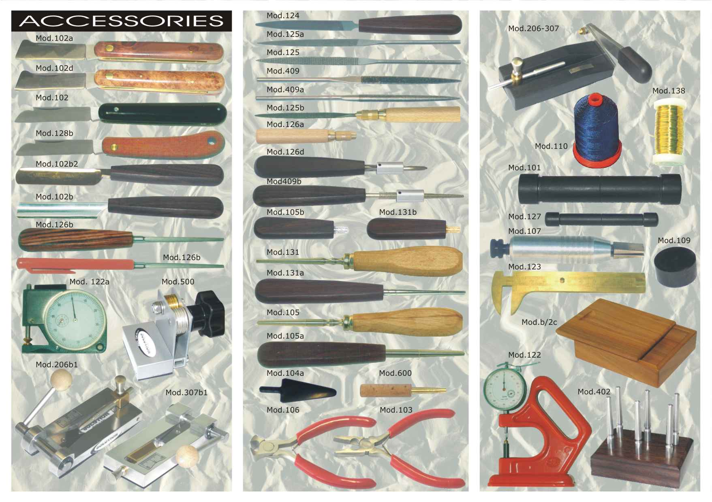

Chevis-F (mod.203)
Available models: |  |  |  |  |  | 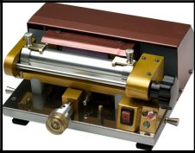 |  |  |  |  |  |  |  |  |  | Support  Clamps  Advancing knob  Rotation knob  Starting button  Power switch
Mod. 200 -  Mod. 203 -  Mod. 204 -  Mod.204b - |  |  | Chevis-F profiler for gouged canes  Chevis-F profiler for gouged and shaped canes  Chevis-F Gold version with case profiler for gouged canes or gouged and shaped canes  Chevis-B profiler for  gouged and shaped  canes for Baroque
Dimension and weight
Height [mm] Length [mm] Width [mm] Weight [gr]
98 170 228 2900
Chevis-F (bassoon mod.203 and mod.204b bassoon Baroque) and Chevis-O (oboe mod.303) are machines designed to make profiled reeds in a very short time without using files and knives.
The cane is fitted on to the clamps over the support, then turn the power switch on ( position 1). Press the starting button and turn the stand by operating the knob until the reed-blank faces the grinding wheel. Turn the advancing knob clockwise until the cane adheres to the grinding wheel, then operate a constant rotating movement with the knob in order to remove the exceeding material on the whole surface of the cane.
The engine stops automatically and indicates the end of the process by a warning light.
It’s possible to install the tracing for to mark the central exact in cane.
Displace the cane from the support, now it is ready to be folded, trimmed and wrapped with coloured thread.
The Profiler is set to attain a standard thickness but it can be adjusted to customers’ own specifications or it can be set using a sampling of reeds and all the essential details to verify the characteristics.
Chevis is in compliance with the regulations concerning safety (EC).
It’s possible to order Chevis transformer for 110 AC or motor 110 Volt.
Chevis-O (Mod. 303)
Available models: |  |  |  |  |  | 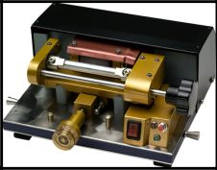 |  |  |  |  |  |  |  |  |  | Support  Clamps  Advancing knob  Rotation knob  Starting button  Power switch
Mod. 300 -  Mod. 303 -  Mod. 304 - |  |  | Chevis-O profiler for gouged canes  Chevis-O profiler for gouged and shaped canes  Chevis-O Gold version with case profiler for gouged canes or gouged and shaped canes
Dimension and weight
Height [mm] Length [mm] Width [mm] Weight [gr]
98 170 228 2700
31030 Altivole (TV) – Via del Molino, 32 - ITALY
Tel. ++39 0423/915549 Fax. ++39 0423/915549 e-mail chevis@libero.it
Windreed-O (Mod.305) Windreed-O (Mod. 305a)
Available models: |  |  |  |  | 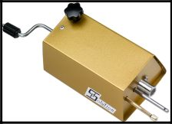 |  |  |  |  |  |  |  |  |  |  |  | 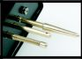  Tapered pin  Empty rod  Holed central stick
Mod. 305 -  Mod.305a- |  | Windreed-O with empty rod wraps and twines the thread at the end of the reed  Windreed-O with tapered pin wraps and twines the thread at the end of the reed
Dimension and weight
Height [mm] Length [mm] Width [mm] Weight [gr]
50 110 74 375
Windreed-O (Oboe mod.305/a) and Windreed-F (Bassoon mod. 205) are portable reed-winding machines which help musicians to give the finishing touch to their reeds. These machines make wrapping with thread much easier and quicker, you just have to put the reed in the tapered pin or in the empty rod, then insert the thread in the hole of the central stick and place it on the threaded stick which serves as a slide guide. Turning the handle with one hand and holding the thread in the other hand, the machine makes a perfect “ball” wrapping with a honeycomb effect every time.
Windreed is in compliance with the regulations concerning safety (EC)

Windreed-F (Mod. 205)
Available models: |  |  |  |  | 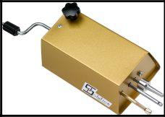 |  |  |  |  |  |  |  |  |  |  |  | 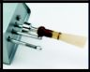  Tapered pin  Holed central stick
Mod.205- |  | Windreed-F with tapered pin wraps and twines the thread at the end of the reed
Dimension and weight
Height [mm] Length [mm] Width [mm] Weight [gr]
50 110 74 375
31030 Altivole (TV) – Via del Molino, 32 - ITALY
Tel. ++39 0423/915549 Fax. ++39 0423/915549 e-mail chevis@libero.it

TECHNICAL FEATURES STANDARD TO MAKE PROFILED SHAPED CANES

WITH CHEVIS-F-O

 | SHAPED CANES FOR BASSON: UPPER VIEW |  |  |  |  |  | SHAPED CANES FOR BASSON: SECTION SIDE
 | 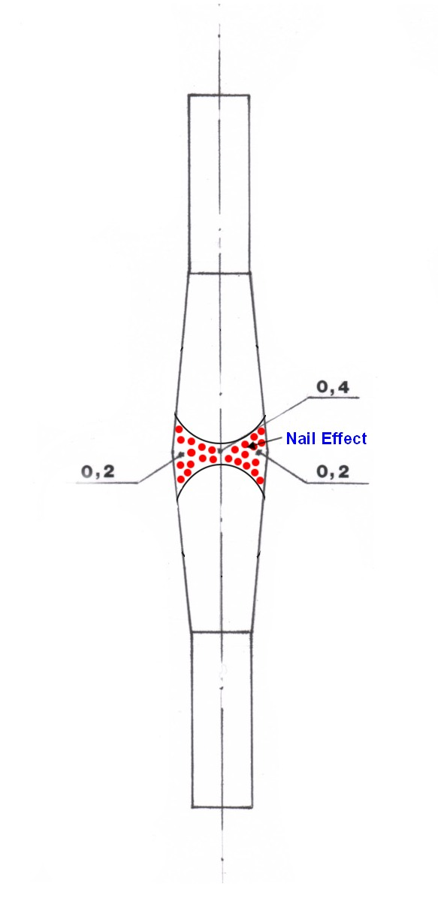 |  |  |  |  |  | Distance  millimetres |  |  |  | Thickness central standard |  |  | RESULTS
 |  |  |  |  |  |  | 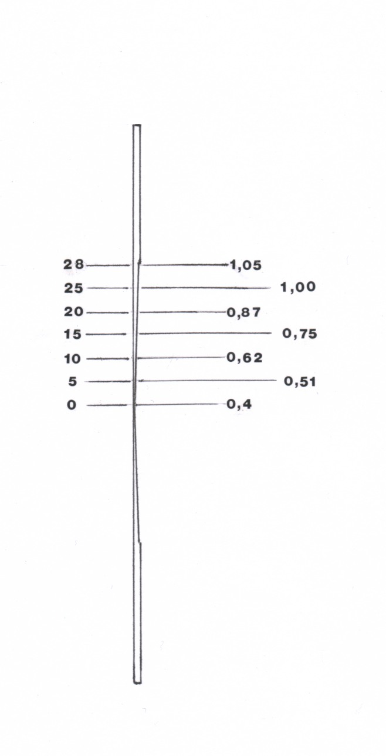 |  |  |  |  |  |  | Technical Features |  |  |  |  | F |  | O
 |  |  |  |  |  |  |  |  |  |  |  |  |  | Length profiled cane |  |  |  |  | 60 mm |  | 25 mm
 |  |  |  |  |  |  |  |  |  |  |  |  |  | Central thickness |  |  |  |  | 0,4 mm |  | 0,35 mm
 |  |  |  |  |  |  |  |  |  |  |  |  |  | Cane end thickness |  |  |  |  | 1,05 mm |  | 0,5 mm
 |  |  |  |  |  |  |  |  |  |  |  |  |  | Angle of inclination |  |  |  |  | X |  | X
 |  |  |  |  |  |  |  |  |  |  |  |  |  | TRANSVERSAL / CENTRAL SECTION
 |  |  |  |  |  |  |  |  |  |  |  |  |  | BASSON  3  1 2 |  |  |  |  | OBOE  3  1 2
 |  |  |  |  |  |  |  |  |  |  |  |  |  | Technical Features |  |  |  |  | F |  | O
 |  |  |  |  |  |  |  |  |  |  |  |  |  | Side thickness (1, 2 ) |  |  |  |  | 0,2 mm |  | 0,2 mm
 |  |  |  |  |  |  |  |  |  |  |  |  |  | Central thickness ( 3 ) |  |  |  |  | 0,4 mm |  | 0,35 mm
 |  |  |  |  |  |  |  |  |  |  |  |  |  | Moon effect manufacture |  |  |  |  | X |  | X
 |  |  |  |  |  |  |  |  |  |  |  |  |  | Nail effect manufacture |  |  |  |  | X |  | X
 | Available Model |  |  | M 1* |  |  |  | M 2** |  |  |  | Grindstone  Ø | Easel  Ø |  | Kg |  |  | Canes  Length |  | Canes  Thickness***
 | Mod. 200- Chevis F |  |  | X |  |  |  |  |  |  |  | 33 mm | 26 mm |  | 2,9 |  |  | 120 mm |  | 1,2 mm
 | Mod. 203- Chevis F |  |  |  |  |  |  | X |  |  |  | 33 mm | 26 mm |  | 2,9 |  |  | 120 mm |  | 1,2 mm
 | Mod. 204- Chevis F |  |  | X |  |  |  | X |  |  |  | 33 mm | 26 mm |  | 2,9 |  |  | 120 mm |  | 1,2 mm
 | Mod. 204b- Chevis F |  |  | X |  |  |  | X |  |  |  | 33 mm | 26 mm |  | 2,9 |  |  | 135-50 mm |  | 1,4 mm
 | Mod. 300- Chevis O |  |  | X |  |  |  |  |  |  |  | 32 mm | 10,6 mm |  | 2,7 |  |  | 75 mm |  | 0,6 mm
 | Mod. 303- Chevis O |  |  |  |  |  |  | X |  |  |  | 32 mm | 10,6 mm |  | 2,7 |  |  | 75 mm |  | 0,6 mm
 | Mod. 304- Chevis O |  |  | X |  |  |  | X |  |  |  | 32 mm | 10,6 mm |  | 2,7 |  |  | 75 mm |  | 0,6 mm

* Clamp for gouged canes 19,5 millimetres (Bassoon) and 8,5 millimetres for (Oboe)
** Clamp for gouged shaped canes 10 millimetres (Bassoon) and 5 millimetres for (Oboe)
*** Thickness recommended to realize high level Reeds
 | BASSOON TOOLS
 | Mod.101  Mod.102  Mod.102a  Mod.102b  Mod.102b2  Mod.102c  Mod.102e  Mod.102f  Mod.128d  Mod.103  Mod.104  Mod.104-1  Mod.104a  Mod.105  Mod.105a  Mod.105a-1  Mod.105b  Mod.105c  Mod.105d  Mod.106  Mod.108  Mod.109  Mod.110  Mod.120  Mod.121  Mod.122  Mod.122-1  Mod.122a  Mod.122b  Mod.123  Mod.124  Mod.125  Mod.125a  Mod.125b  Mod.125c  Mod.126  Mod.126a  Mod.126b  Mod.126c  Mod.126d  Mod.126d1  Mod.126d2  Mod.401  Mod.402  Mod.403  Mod.403a  Mod.403b  Mod.404  Mod.405  Mod.406  Mod.408  Mod.409  Mod.409a  Mod.409b  Mod.409b  Mod.200  Mod.200-m  Mod.202  Mod.203  Mod.204  Mod.204b  Mod.204c  Mod.204c1 Mod.204c2  Mod.205  Mod.400  Mod.400-1  Mod.500  Mod.501  Mod.206  Mod.206b1  Mod.206b2  Mod.206b3  Mod.B/3  Mod.B/4 | Bassoon easel in ebony……………………………………………………………………………………………………….  Clasp knife………………………………………………………………………………………………………………………  Clasp knife (cherry)…………………………………………………………………………………………………………….  Tempered steel knife, razor type, to finish reed “special professional model”…………………………………………...  Tempered steel knife, razor type "thin" professional model……………………………………………………………….  Clasp knife shape “moon”……………………………………………………………………………………………………..  Tempered steel knife, razor type “Graft”…………………………………………………………………………………….  Tempered steel knife, razor type, pocket…………………………………………………………………………………….  Clasp knife pocket (4 blade type)……………………………………………………………………………………………..  Pliers……………………………………………………………………………………………………………………………..  Pliers with hole………………………………………………………………………………………………………………….  Pliers with triple utility type Rieger……………………………………………………………………………………………  Plastic Bassoon convex plaque spade……………………………………………………………………………………….  Bassoon mandrel wood handle……………………………………………………………………………………………….  Bassoon mandrel rosewood handle “special” type Rieger ………………………………………………………………..  Bassoon mandrel rosewood handle “special” type Pfeiffer………………………………………………………………...  Bassoon mandrel rosewood handle “pocket”………………………………………………………………………………..  Handle for interchangeable mandrel/reamer Ø 6…………………………………………………………………………...  Bassoon mandrel type Rieger (without handle) …………………………………………………………………………….  Flat cutting-pliers for reeds (12 mm-15 mm) ………………………………………………………………………………..  Bassoon cane splitter rosewood handle …….………………………………………………………………………………  Cutting block in ebony .………………………………………………………………………………………………………..  Nylon thread 825 mt. blue, red, black, etc. …….……………………………………………………………………………  Nylon thread 600 mt. multicolor …….………………………………………………………………………………………..  Brass thread Ø 0,6 mm (12 m.) …….……………………………………………………………………………………...…  Dial-indicator of cane-thickness …….………………………………………………………………………………………..  Dial-indicator of reed-thickness…….…………………………………………………………………………………………  Dial-indicator of cane-thickness pocket…….………………………………………………………………………………..  Dial-indicator of reed-thickness pocket…….………………………………………………………………………………...  Caliper for reed length…….……………………………………………………………………………………………………  Small file with wooden handle…….………………………………………………………………………………………..…  Rasp for finishing…….…………………………………………………….………………………………………………...…  Small file “flat” …….…………………………………………………….……………………………………………………..  Rasp for finishing with wooden handle …….…………………………………………………….………………………….  Small file “flat” with wooden handle …….…………………………………………………….……………………………...  Kit 6 small file with wooden handle (case) …….…………………………………………………….………………………  Handle for interchangeable small file …….…………………………………………………….……………………………  Sharpener for clasp knife (pocket) …….…………………………………………………….……………………………….  Kit for sharpening knives (2 honingstones + 1 special oil for stone) KENSIS……………………………………………  Bassoon reamer 5 cutting-edges……………………………………………………………………………………………..  Bassoon reamer 5 cutting-edges(with regulator)……………………………………………………………………………  Bassoon reamer 5 cutting-edges(without handle)…………………………………………………………………………..  Reed drying board 3 pins ………………………………………………………………………..……………………………  Reed drying board 6 pins………………………………………………………………………………………………………  Reed drying board 12 pins ……………………………………………………………………………………………………  Reed drying board without 12 pins……………………………………………………………………………………………  Reed drying board(All.Avional) 12 pins (brass)……………………………………………………………………………..  Bassoon shaper tip (1 - 2 - 3) ………………………………………………………………………………………………..  Bassoon handle for tips ……………………………………………………………………………………………………….  Bassoon cane scraper ………………………………………………………………………………………………………...  Spring-hook with handle ………………………………………………………………………………………………………  Diamond small file “warding” (without handle)………………………………………………………………...…………….  Diamond small file “halfround” (without handle)…………………………………………………………………………….  Diamond reamer ……………………………………………………………………………………………………………….  Diamond reamer with regulator……………………………………………………………………………………………….  SMALL MACHINE  Chevis-F machines designed to make profiled gouged canes……………….……………………………………………  Accessories for Chevis transformer for 110 AC or motor 110 Volt…………………………..……………………………  Small suitcase for Chevis…………..………………………………………………………………………………………….  Chevis-F machines designed to make profiled gouged shaped canes …………..……………………...………………  Chevis-F version with small suitcase machines designed to make profiled gouged canes/gouged shaped canes…  Chevis-B machines designed to make profiled gouged canes and shaped for Bassoon Baroque……………………  Tip profiling machine (reed) type Rieger standard model………..………………………………………………………..  Replacement blade, for tip profiling………..…………………………………………………………………………………  New pattern block for profiling machine, on account of a sample made by the customer……………………………...  Windreed-F with tapered pin wraps and twines the threads at the end of the reed …………………………….……..  Chevis to make profiled gouged shaped canes model would like the customer …………………………….………….  Chevis accessory for tracing half cane………..…………………………………………………………………………….  Cut-cane height adjustable 10 to 25 mm No. Of cuts: 6 ………..………………………………………………………..  Machine for to draw lengthwise 90° the cane to 20 mm. for Bassoon and Baroque (mod.Danzi) ……………………  CUT-REEDING  Cut-reeding in ebony with mandrel………..………………………………………………………………………………….  Cut-reeding professional model in Alluminion Avional………..………………….………………………………………..  Cut-reeding professional model in Alluminion Avional pocket…………………………………………………………….  Cut-reeding professional model in brass pocket………..…………………………………………………………………..  ACCESSORIES-CASE  Bassoon accessories-case made in real leather pocket ………..………………………………………………………..  Bassoon accessories-case made imitation of leather pocket - woven ………………………………………………….. | € 11,90  € 5,95  € 8,15  € 23,90  € 13,70  € 5,50  € 19,80  € 12,70  € 6,00  € 5,99  € 7,95  € 20,50  € 0,99  € 6,80  € 9,95  € 9,95  € 13,90  € 7,90  € 7,40  € 6,28  € 29,00  € 2,90  € 5,90  € 4,90  € 2,30  € 59,90  € 69,90  € 68,10  € 79,90  € 10,90  € 5,20  € 5,70  € 5,40  € 8,40  € 8,50  € 19,80  € 3,70  € 9,20  € 9,90  € 20,49  € 22,19  € 18,45  € 7,70  € 9,20  € 16,20  € 7,10  € 29,70  € 35,20  € 45,90  € 17,10  € 7,30  € 14,00  € 14,00  € 33,30  € 35,30  € 572,72  € 23,90  € 24,00  € 596,34  € 668,50  € 716,50  € 657,60  € 23,90  € 148,00  € 136,80  € 49,00  € 40,00  € 26,90  € 576,72  € 25,60  € 53,90  € 64,10  € 68,10  € 26,90  € 18,80

 | OBOE TOOLS
 | Mod.102  Mod.102a  Mod.102b  Mod.102b2  Mod.102e  Mod.102f  Mod.128d  Mod.103  Mod.106  Mod.122  Mod.122-1  Mod.122a  Mod.122b  Mod.123  Mod.124  Mod.125  Mod.125a  Mod.125b  Mod.125c  Mod.126  Mod.126a  Mod.126b  Mod.126c  Mod.127  Mod.130a  Mod.131a  Mod.131b  Mod.135  Mod.136  Mod.137  Mod.138  Mod.148  Mod.149  Mod.150  Mod.151  Mod.152  Mod.153  Mod.408-1  Mod.409  Mod.409a  Mod.300  Mod.200-m  Mod.202  Mod.303  Mod.304  Mod.400  Mod.400-1  Mod.305a  Mod.302  Mod.302a  Mod.302b  Mod.307  Mod.307b1  Mod.307b2  Mod.307b3  Mod.B/3  Mod.B/4  Mod.600  Mod.620  Mod.630  Mod.640  Mod.650  Mod.660  Mod.670 | Clasp knife……………………………………………………………..…………………………………………….……….…  Clasp knife (cherry)……………………………………………………………………………………………………………. Tempered steel knife razor type, to finish reed “special professional model”……………………………………………  Tempered steel knife, razor type "thin" professional model ………………………………………………………………  Tempered steel knife, razor type “Graft”…………………………………………………………………………………….  Tempered steel knife, razor type, pocket…………………………………………………………………………………….  Clasp knife pocket (4 blade type)……………………………………………………………………………………………..  Pliers……………………………………………………………………………………………………………………………..  Flat cutting-pliers for reeds (12 mm) …………………………………………………………………………………………  Dial-indicator of cane-thickness …….………………………………………………………………………………………..  Dial-indicator of reed-thickness…….…………………………………………………………………………………………  Dial-indicator of cane-thickness pocket…….………………………………………………………………………………..  Dial-indicator of reed-thickness pocket…….………………………………………………………………………………...  Caliper for reed length…….……………………………………………………………………………………………………  Small file with wooden handle…….………………………………………………………………………………………..…  Rasp for finishing…….…………………………………………………….………………………………………………...…  Small file “flat” …….…………………………………………………….……………………………………………………..  Rasp for finishing with wooden handle …….…………………………………………………….………………………….  Small file “flat” with wooden handle …….…………………………………………………….……………………………...  Kit 6 small file with wooden handle (case) …….…………………………………………………….………………………  Handle for interchangeable small file …….…………………………………………………….……………………………  Sharpener for clasp knife (pocket) …….…………………………………………………….……………………………….  Kit for sharpening knives (2 honingstones + 1 special oil for stone) KENSIS……………………………………………  Oboe easel in ebony ………………………………………….……………………………………………………………….  Plastic Oboe convex plaque.…………………………………………………….…………………………………….………  Oboe mandrel elliptical wooden handle “special” .…………………………………………………….……………………  Oboe mandrel elliptical wooden handle “pocket” .…………………………………………………….……………………  Cutting block in ebony …….…………………………………….…………………………………………………………….  Nylon thread 1650 mt.. blue, red, etc. .…………………………………………………….………………...………………  Nylon thread 1200 mt.. multicolor .…………………………………………………….…………………………………..…  Brass thread Ø 0,4mm .…………………………………………………….………………………………………………….  Oboe shaper tip (1 - 2 - 3) .…………………………………………………….……………………………………………..  Oboe handle for tips .…………………………………………………….…………………………………………………….  Oboe cane scraper .…………………………………………………….……………………………………………………...  Tube drying board without 12 pins……………………………………………………………………………………………  White bladder……………………………………………………………………………………………………………………  Oboe cane splitter wooden handle.…………………………………………………….……………………………………  Octave insert remover with handle.……… ……………………………………..…………………………………………..  Diamond small file “warding” (without handle)………………………………………………………………...…………….  Diamond small file “halfround” (without handle)……………………………………………………………...…………….  SMALL MACHINE  Chevis-O machines designed to make profiled gouged canes……………………………………………………………  Accessories for Chevis transformer for 110 AC or motor 110 Volt………………………………………………………..  Small suitcase for Chevis………………………………………………………………………………………………………  Chevis-O machines designed to make profiled gouged shaped canes ………………………………………………….  Chevis-O version with small suitcase machines designed to make profiled gouged canes/gouged shaped canes...  Chevis to make profiled gouged shaped canes model would like the customer ………………………………………..  Chevis accessory for tracing half cane………………………………………………………………………………………  Windreed-O with tapered pin twines the threads at the end of the reed…………………………………………………  Shaping machine with shaperform standard………………………………………………………………………………..  Customized shaperform………………………………………………………………………………………………………..  Spareblade  CUT-REEDING  Cut-reeding in ebony ……………...………..………………………………………………………………………………….  Cut-reeding professional model in Alluminion Avional ……………………………………………………………………..  Cut-reeding professional model in Alluminion Avional pocket…………….……………………………………………….  Cut-reeding professional model in brass pocket………..…………………………………………………………………..  ACCESSORIES-CASE  Oboe accessories-case made in real leather pocket ………..………………………………..……………………………  Oboe accessories-case made imitation of leather pocket - woven …..………………………………..…………………  Oboe brass tube (without welding) professional 47 mm …..………………………………..……………………………  DOUBLE REED CANE - DOUBLE REEDS FOR BASSOON  Bassoon shaped and profiled cane ”s. solution” (10 pcs.)central thickness 0,40 mm ……..…….……………...……  Bassoon shaped and profiled cane “m. solution” (10 pcs.)central thickness0,45 mm….…..……...…….…………….  Bassoon shaped and profiled cane “h. solution” (10 pcs.)central thickness 0,50 mm……..………………….………  Bassoon shaped and profiled cane “professional model solution” (10 pcs.) ……..…………………...……….………  Professional Bassoon reed “Solution” ………………………………………………….……………………………………  Student Bassoon reed “Solution” …………………………………………………………………………………………… | € 5,70  € 8,20  € 23,90  € 13,70  € 19,80  € 12,70  € 6,00  € 5,99  € 5,98  € 59,90  € 69,90  € 68,10  € 79,90  € 10,90  € 5,20  € 5,70  € 5,40  € 8,40  € 8,50  € 19,80  € 3,70  € 9,20  € 9,90  € 6,40  € 0,79  € 9,70  € 14,98  € 2,70  € 9,10  € 6,90  € 2,70  € 34,60  € 42,46  € 15,90  € 9,10  € 2,69  € 28,00  € 8,20  € 14,00  € 14,00  € 561,40  € 23,90  € 24,00  € 585,84  € 636,68  € 49,00  € 40,00  € 136,80  € 399,90  € 90,00  € 14,00  € 25,60  € 53,90  € 64,10  € 68,10  € 26,90  € 18,80  € 1,49  € 15,80  € 15,80  € 15,80  € 18,90  € 17,90  € 9,90

